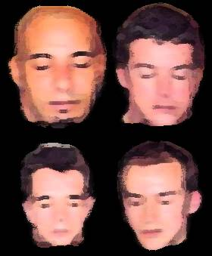

Live at the Walthamstow Standard,
May 22nd, Onstage 21.15
Opposite Blackhorse Road Tube
£4 Admission

