
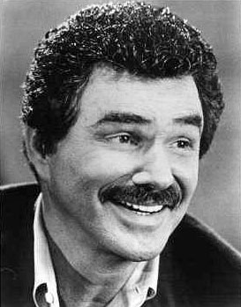
Live At The Marquee
1 Leicester Square, WC2H 7NA
Tuesday, 22nd March 2005
Onstage 8pm. Tube – Leicester Square

